Development Journal: PHP Test Apparatus (PHPA)

# 01/14/2020

Spent most of the day working on remedial tasks / installing Solidworks. Began work on the design late today.

Design needs to rotate around two axes as the heat-pipe performance will vary depending on angle during operation.

Build around 35x35mm NEMA stepper motors. The design should be modular in nature to allow for adjustments of heat-pipe dimensions and configurations.

Will use an Arduino to control the precise position of the stepper motors to allow for accurate angular adjustments

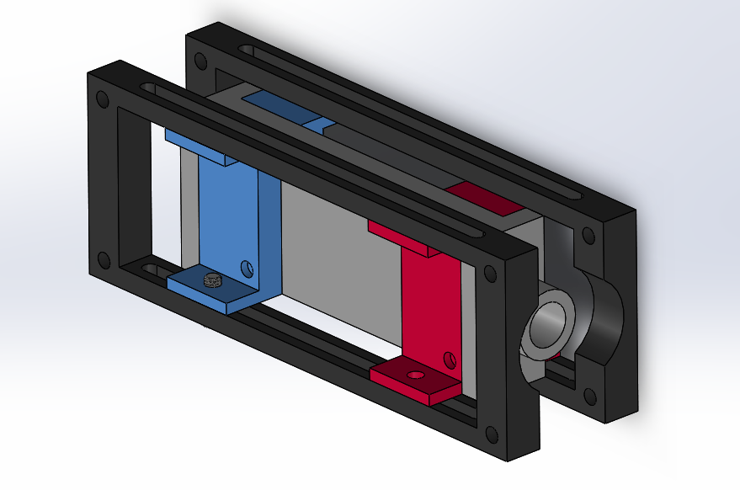

# 01/15/2020

First iteration of heat-pipe mount complete. Allows for variation in length and height. Width dimension is constrained as all branched heat-pipe test articles are the same.

Completed design of stand and motor mounts. Still need to design a way to allow the motor axles to mount efficiently to the motor mount. Seems like it might not be strong enough? To be reviewed.

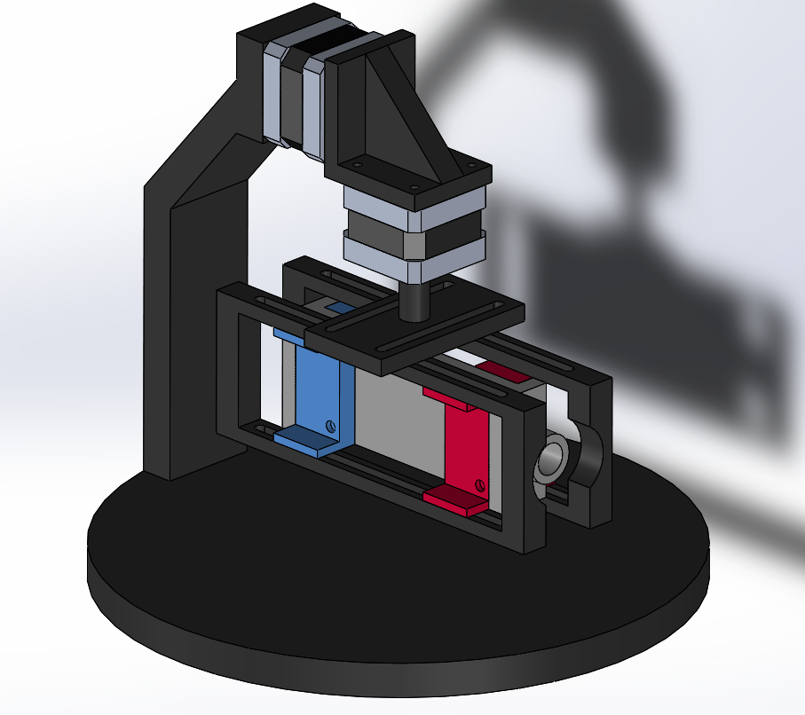

Need to adjust for insulation between plastic component and heat pipe.

Need to figure out an efficient way to orient the rotation axes such that they minimize torque on the motor shafts, but also leave room for a large enough heat-pipe test article mount.

# 01/16/2020 – Design Change

After meeting with Ezra, Paht, and Arman, the design is to be adjusted. Design will change to a completely mechanical approach (no motors or electronics).

**ADDED:**

* Hardware from McMaster Carr.
* Adjusted measurements to allow for hand/wing nut room.

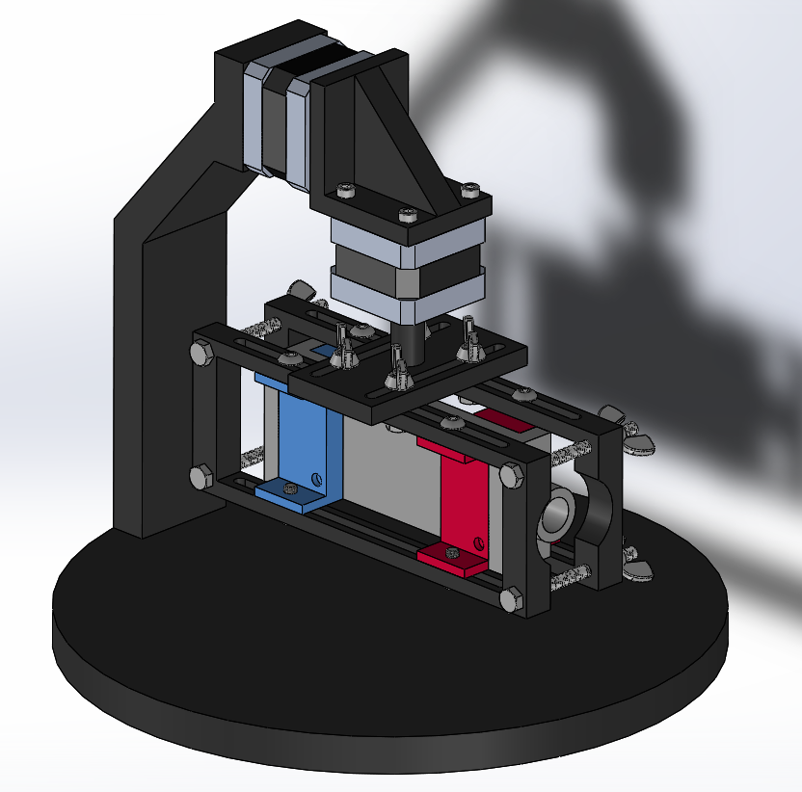

New Requirements for heat pipes:

1. Must be able to withstand $10°C-100°C$
2. Preferred: Fluids must contact the test piece (Viton Sheet?)

**TO ADD (after redesign):**

* Complete Parameterization
* 3D Printing Clearances (after testing)
* Insulation
* Gaskets
* Omega Turbine Liquid Flow Meters (?)

**Modifications:**

* Purchased heating/cooling blocks (?)
* Design thermal block large enough for constant temperature
* Mechanical axes
* Angle indicators
* Detachable arm

First order of business: Figure out how to create a fully mechanical, incremental (every 5 degrees) stepper.

Attempts:

* Worm gear actuation (too complex to print reliably)
* Pressure mounting (I don’t think this will be secure enough).

Ideas:

* Push and pull?
* Longworth chuck?
* Something else?

Also, some basic structures math to verify that the weakest point in the design (the M3 mounting slots) can withstand reasonable shear forces. To check that the mounting hole won’t shear, I took the most conservative estimate for ABS plastic with a yield stress of 13 MPA (the real plastic we are using is ~30 MPA) and found the area of the slot that could potentially shear away from the rest of the plastic. This yielded a result that someone would have to apply 400 lbs of force to shear these bolt slots. This design will not be experiencing those forces.

$S_{y}=\frac{F}{A} → 13MPA=\frac{F}{141.37 mm^{2}} → F≅1.8 KN≅400 lbf$ (incorrect)

# 01/17/2020

I’m realizing that just about every component will need to be redesigned except for the heat-pipe module. First order of business is to design a proper intermittent mechanical stepper.

The first idea was to create a push to unlock, then rotate, and release to lock mechanism:

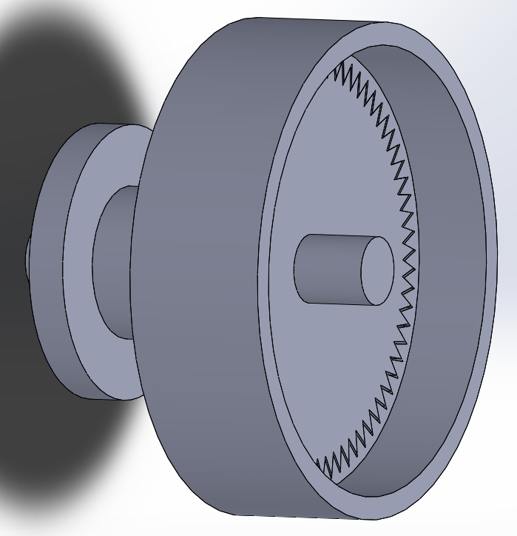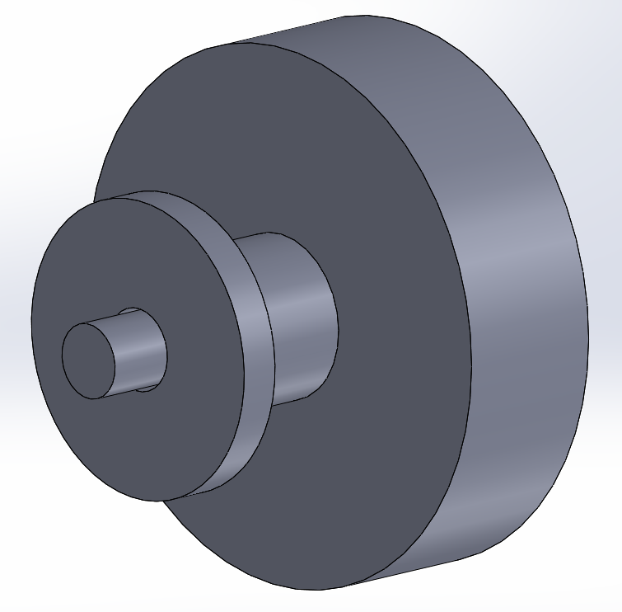

You would use two fingers to grab the small disk, use your thumb to push in the button which would move the teeth away from the grooves, allowing the outer shell to rotate. Unfortunately, it would require a spring to hold the teeth in place after releasing the button. Because these mechanical steppers will be at so many different possible angles, a spring could be unreliable, and if it is strong enough to be reliable at odd angles, it may require an uncomfortable amount of force to apply on with your thumb. All of this could be accounted for and tested, but I believe there is a simpler way to approach this.

I think a Longworth Chuck would be an interesting approach. Possibly not the simplest design, but could be the simplest and easiest to operate for the user…

* Began writing code for automatic Longworth arc designer, did no complete as it was not going to be convenient enough to warrant actual development time 1//20/20 (superseded)

After lots of trial, error, and research, I finally discovered a proper and easy way to create a Longworth Chuck. Surprisingly it was not easy to find, and there is no clear math on how to define the curves that the bolts will slide in. So, I went with a drafting method:

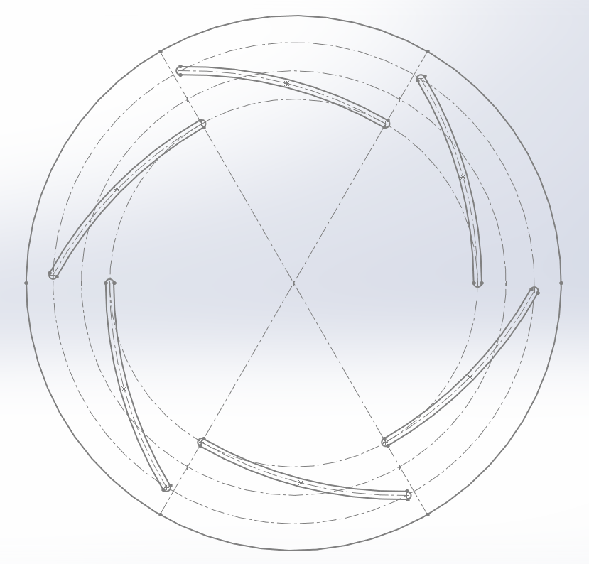

Sketch lines at equal angular displacements. Establish boundaries for inner and outer limits of the arc-slots. Draw a circle symmetrically between boundaries. Choose the coincident point between one of the lines and the center arc as the center point of the arc. Then, 180 degrees offset from that point, draw the arc from the inner boundary to the outer boundary. Repeat for all slots.

First idea:

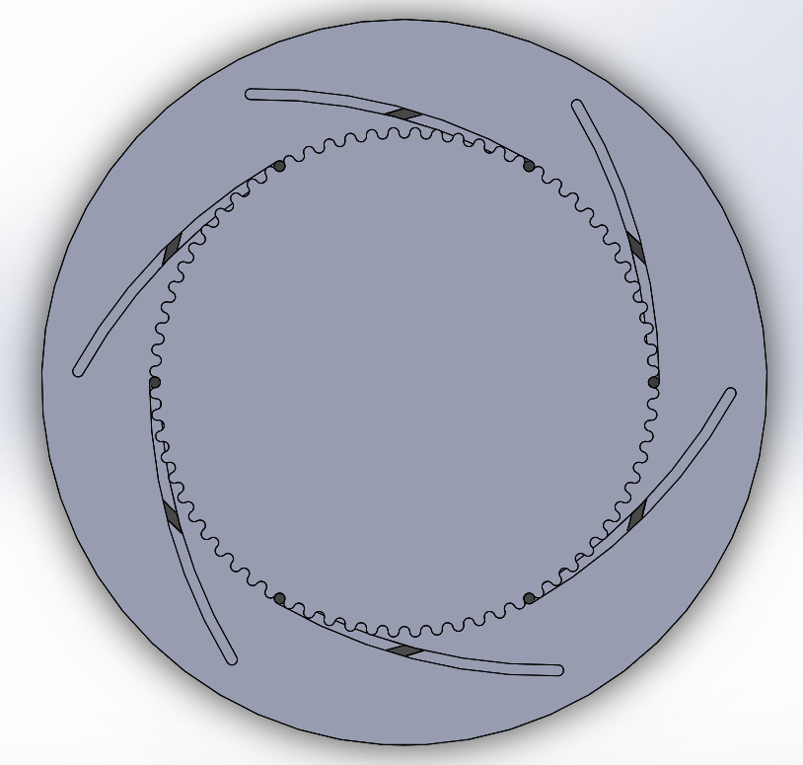

In my mind I was thinking that as long as both the back plate and front plate (behind the gear) could rotate at the same right, the circular center generated (see above) would linearly approach the gear-locking mechanism at the front. Upon further consideration, I realized that this would be a difficult method both to operate and to mount to the test stand.

Idea 2:

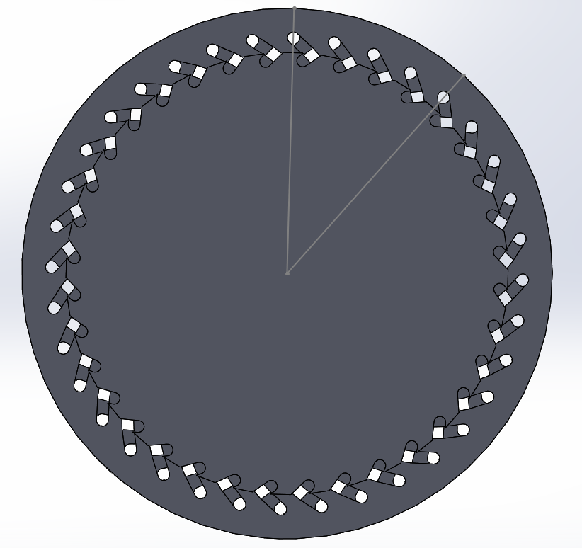

Unlocked Position

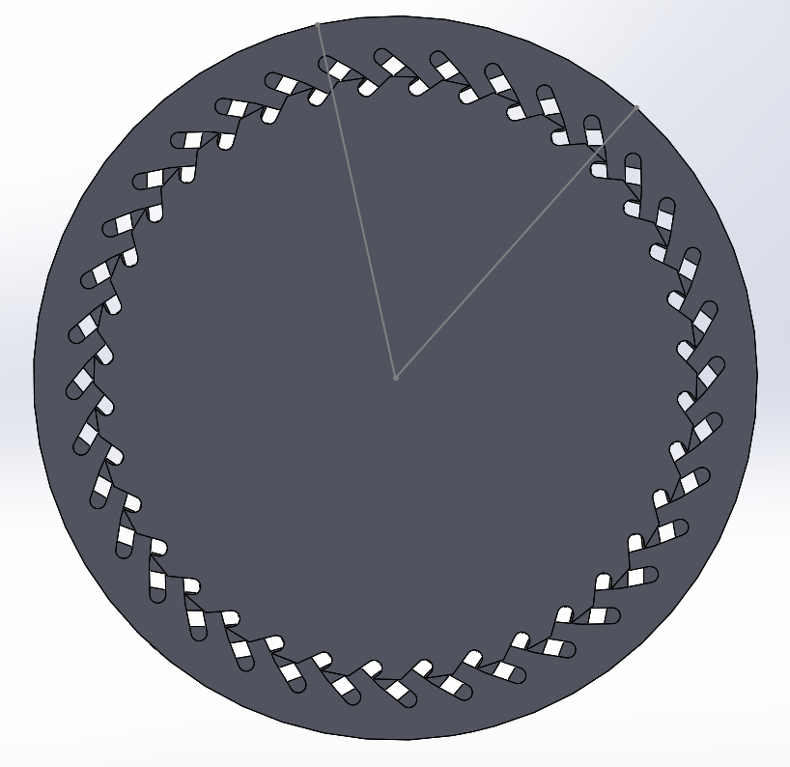

Locked Position

This idea seemed promising to me at first, as it allowed for only one plate to rotate, making it easy to mount and easy to operate. It was also very thin and took up very little space. However, in order to accomplish this, I had to change the incremental locking to 10 degrees per increment instead of the original goal of 5 degrees. This is because the geometry for the bolts that would be placed in these slots became too small at 5 degrees per increment. There is still a problem with this design, however. If torque is applied to the disk counterclockwise, the disk will remain locked. If torque is applied clockwise, the design will unlock, rendering this component useless for this application. I cannot think of an efficient way around this problem without over complicating it.

# 01/20/2020

Over the weekend I had an idea for the mechanical stepper. I believe it will operate similarly to a clutch. The idea is to have one component with slots every 5 degrees emanating from the center of a circular face. The complementary component will have tabs that will slide into these slots when pressure is applied from the normal direction. Then, if torque is applied either clockwise or counterclockwise, the design will remain locked. To be demonstrated…

Idea:

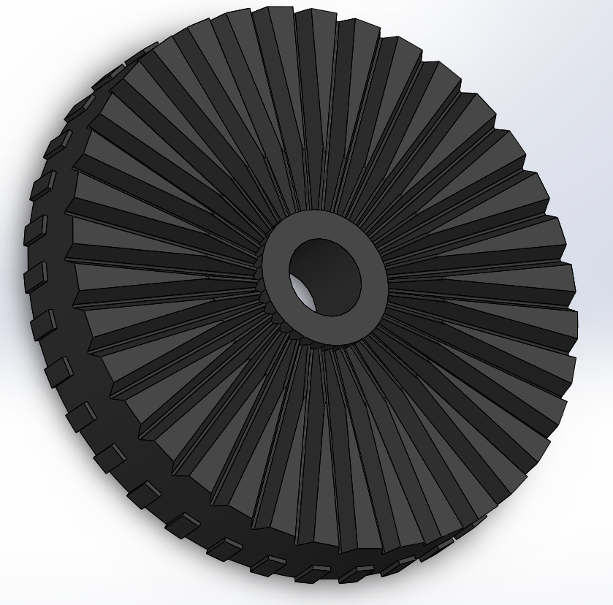

“Clutch” plate with slots (female)

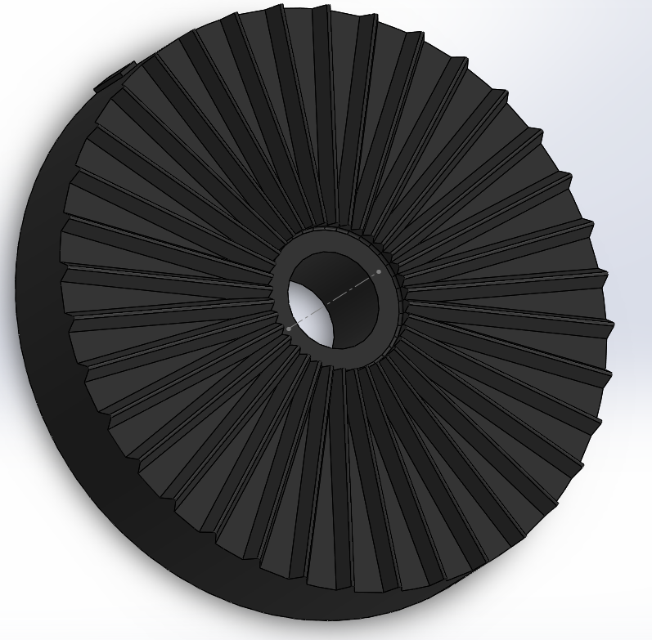

“Clutch” plate with tabs (male)

After designing many variations of these parts and seeing them instead of just picturing them in my mind, I see no problems with the above pictured design. However, I need to figure out a way to mount them to the stand! Also, the same problem still occurred, I could only go down to a resolution of 10 degrees per increment, otherwise I felt that the geometry would be too small to 3D print reliably.

Tabs were included to help the user see how many increments of 10 degree they have rotated the plate.

Mounting Solution:

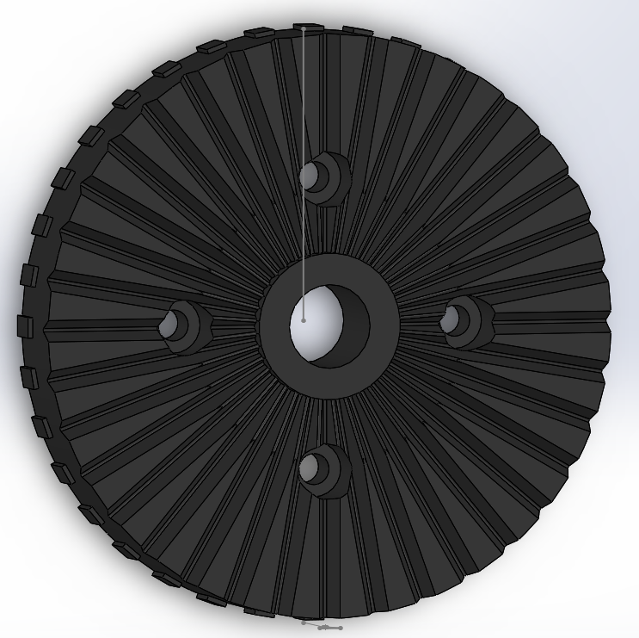

Perhaps a sub-optimal mounting solution, but I need to move on from this problem. I increased thickness of the parts to allow for low profile M3 bolts to go through the 4 slots. I think most other solutions would have added extra bulk and I’m trying to minimize complexity and weight.

Assembly:

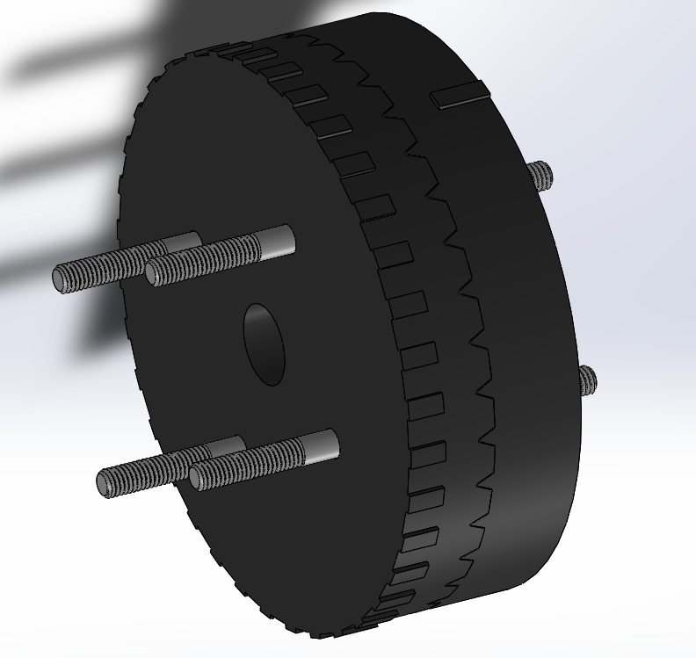

# 01/21/2020

I’m going to leave out the repetitiveness and mistakes made in this post. Essentially, after some trial and error, I created an inter-stepper mount assembly, readjusted the measurements for the heat-pipe module, and made the arm stand arm removable. The base needs to be redesigned.

I also did some other work for my co-op.

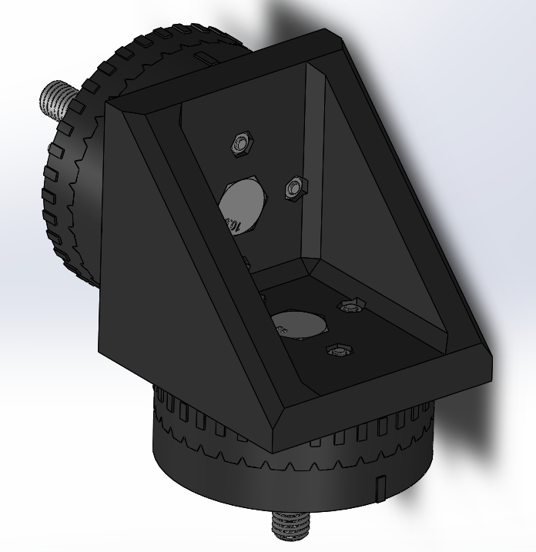

Inter-stepper mount assembly

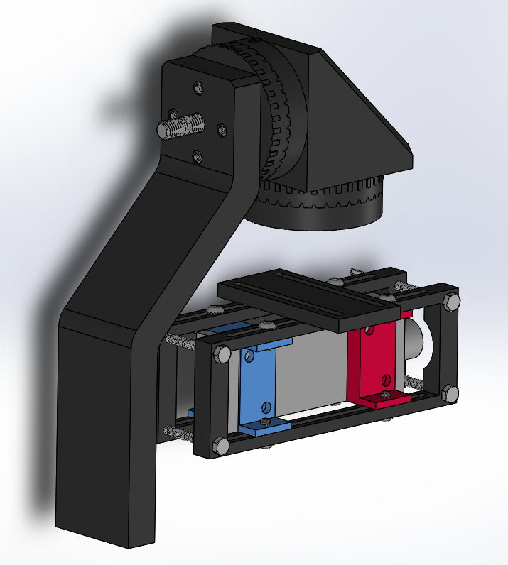

The assembly so far…

# 01/22/2020

I created a base:

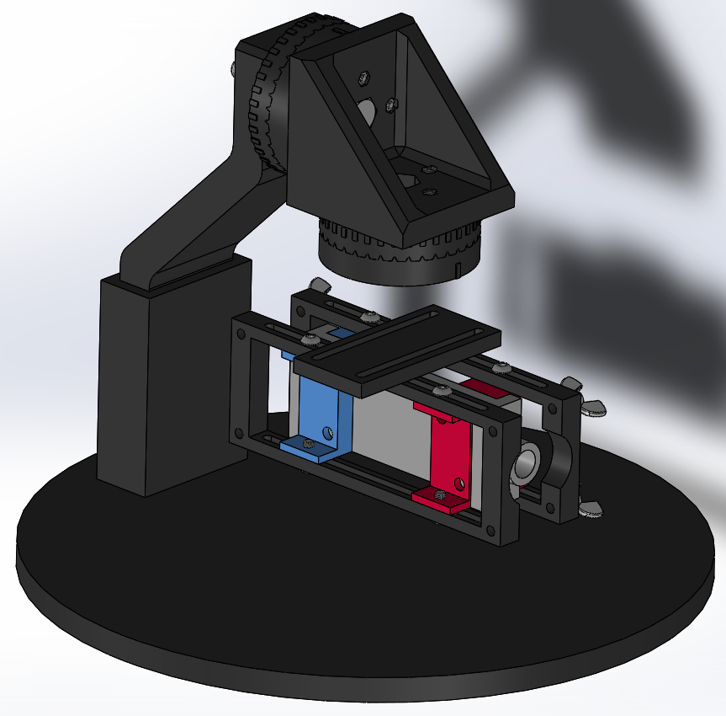

It took a long time to figure out what type of component would mount effectively between the heat-pipe module and the mechanical stepper that would still leave room for human operation, disassembly/reassembly, and allow the application of pressure along the rotation axis when the system needs to be locked. After many iterations and designed parts that I threw away, I arrived at this design:

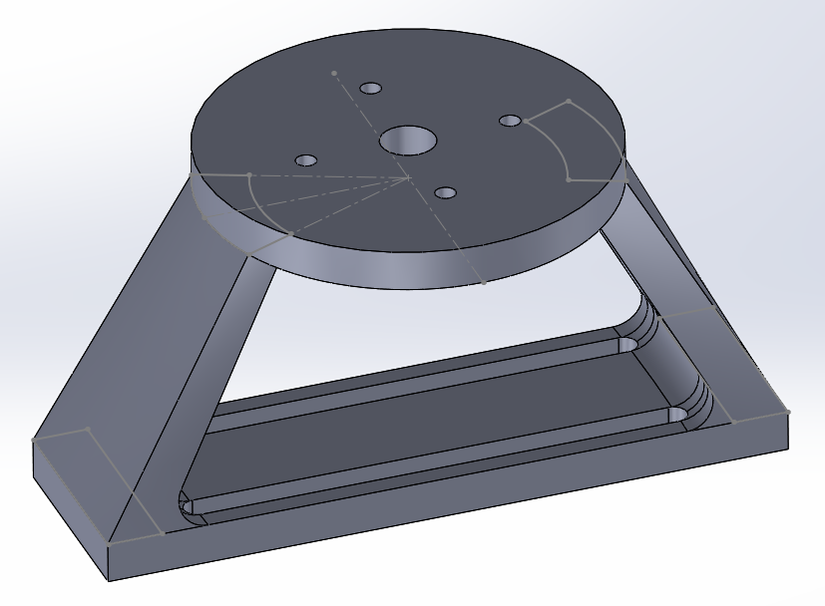

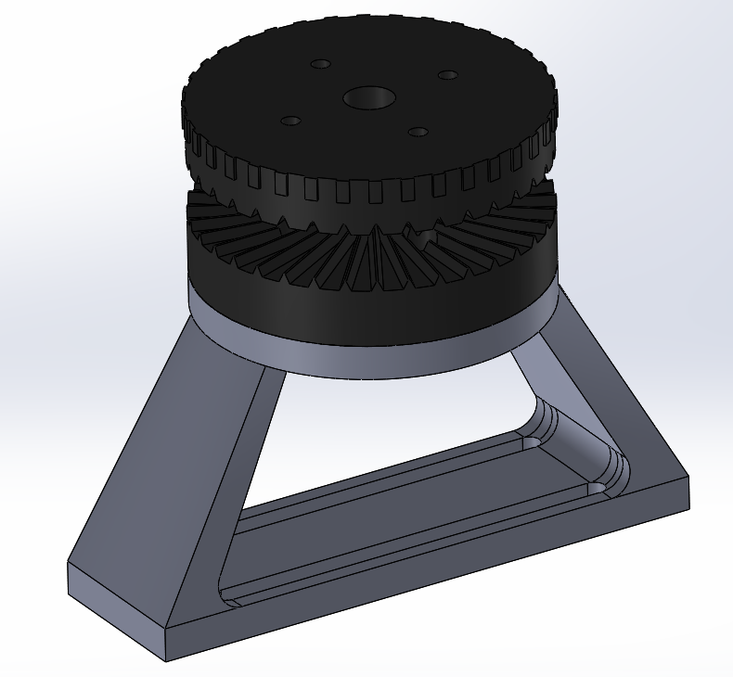

I’ve realized that the complexity of this geometry would make it not only difficult to print, but would create a variety of unnecessary stress concentrations that I don’t think make sense to impose for the sake of aesthetics (and the aesthetic really isn’t that great).

Time for a redesign…

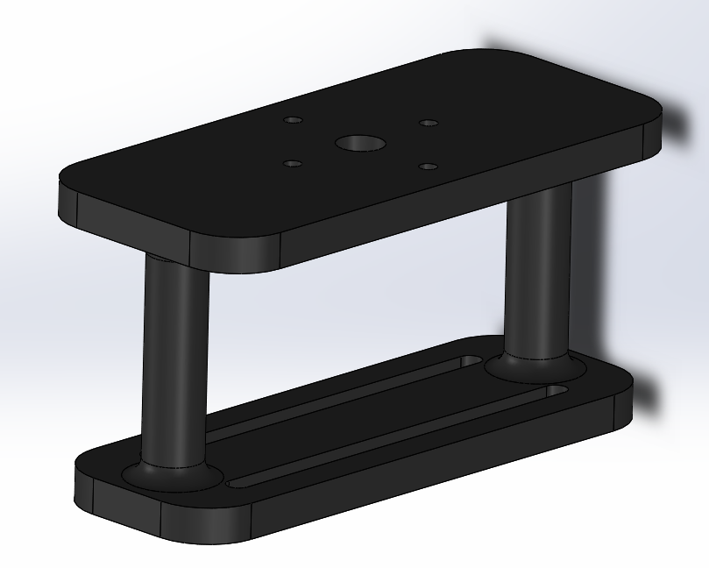

Much better. Obeys the K.I.S.S principle, leaves less room for unnecessary stresses, and leaves room for a human hand.

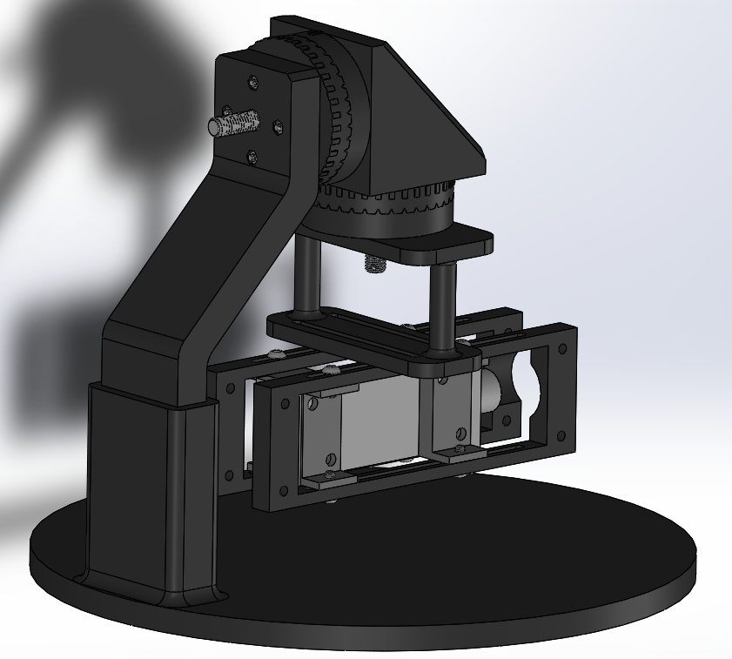

Base design and assembly so far.

I don’t want to use wing nuts for the design anymore as they get in the way and just don’t quite look as professional as it should.

Lucas suggested that I add an adjustable slot to the stand arm such that the height may be easily adjusted. Good idea! Will add tomorrow.

# 01/23/2020

I designed twist knobs to replace the wing nuts and made some preliminary guesses for the clearances required for this design. Most of the day was taken up by other tasks, getting oriented with the lab, meeting people, Co-Op assignment, etc. Here is the current state of the design.

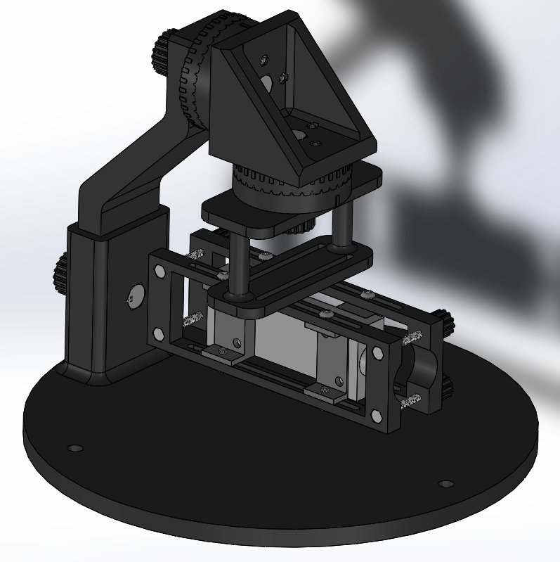

# 01/24/2020

Today requires a change of pace. I purchased some nuts yesterday that will allow me to check the performance of the printer (shrinkage, warping, fitment, etc.) and therefore update some of the clearances required for the design. I am going to print a test piece that will have a control (no clearance), 0.1 mm, 0.2 mm, 0.4mm, and 0.6 mm. I am also going to 3D print a couple of knobs and see how the M8 bolts fit.

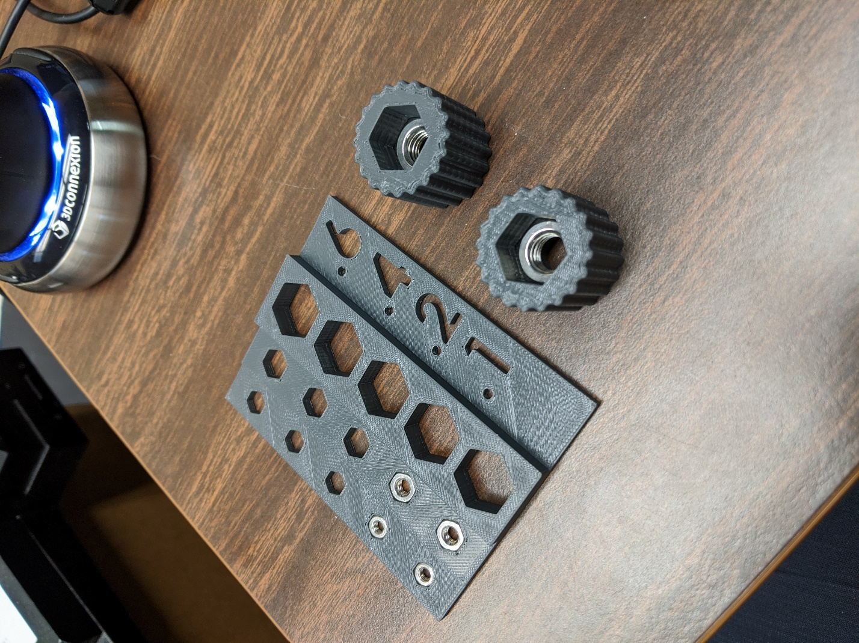

It turns out the nuts that I purchased were undersized by anywhere from 0.1 to 0.2 mm. The ABS plastic also shrank by about 0.1mm and warped slightly. It seems that the safest approach would be to build in a 0.2mm clearance based around the actual size of the nuts. This requires that I get a finished version of the design before I order parts, so I’m not wasteful in what I order. This also means I need to figure out the design of the thermal blocks, what gasket to use, and what insulation to use.

I added the height adjustability to the arm stand, and updated the thicknesses on the heat-pipe module, and removed the mounting hardware as I believe I will have to continue adjusting this module when adding the insulation, gasket and increasing the size of the thermal blocks.

Current state of the design:

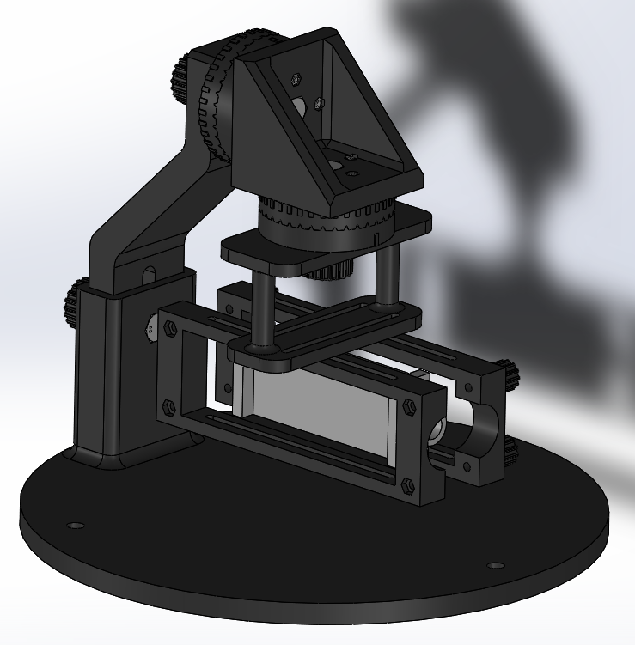

# 01/26/2020

I spent a significant portion of the morning editing my Work Plan and putting my notes together into this development journal. Now I am going refine some clearances for the mechanical stepper, ~~convert to STL, and print a couple test pieces.~~

I have completed adding clearances to all the parts and attaching them to global equations such that they can be easily adjusted. I have just received access to the i-Lab which has 3D printers capable of printing at finer resolutions, therefore I am going to delay printing more test pieces until I can use these printers. A minimum layer height of ~0.175, and accuracy of +/- 0.2 mm on the Fortus 250mc ABS printer gives too much room for error when trying to predict how “snug” a fit will be.

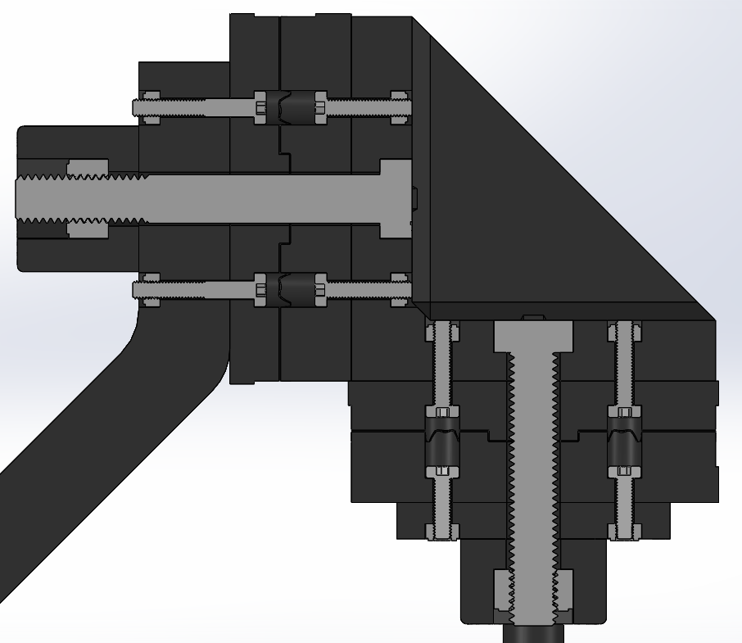

Worked on calculations for thermal blocks for the rest of the day. File saved as ~~Thermal_Calculations.m~~ Thermal_Block_Calculations.m in the Test Stand > Code folder.

* Need information on mass flow rate from heating and cooling reservoirs to help size the thermal blocks.
* Possibly going with the Onyx material as a solution for the thermal blocks? Very low thermal conductivity (0.25 W/mK) compared to Inconel (15 W/mK) which should help with heat retention in the fluid. The deflection temperature is 145 C at 66 psi (0.45 MPA).
* The onyx also has a tensile stress of 36 MPA which is substantial improved over the conservative 13 MPA estimate I used for my basic structural calculations above. This design will be over-built for its intended purpose.

# 01/27/2020

Lots of tertiary work today (tour, applications, etc); waiting on orientation for the iLab to begin printing test pieces, as well as waiting for software installation on the work laptop. I got access to the Markforged Eiger software and iLab Slack channel, however.

Tody I gathered data regarding the feasibility of constructing a thermal block from Onyx (treating it like a pressure vessel). Structural calculations for allowable loads, internal pressures, and expected gasket performance are documented in the Thermal_Block_Calculations.m file.

Tentative Design for the thermal blocks including insulation and gasket(I’m uncertain about a rectangular pressure vessel):

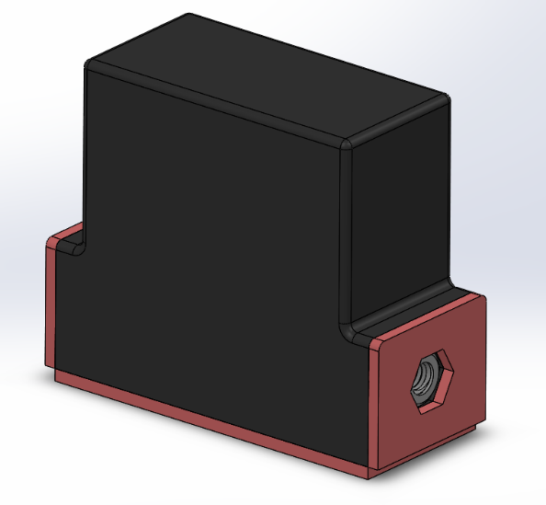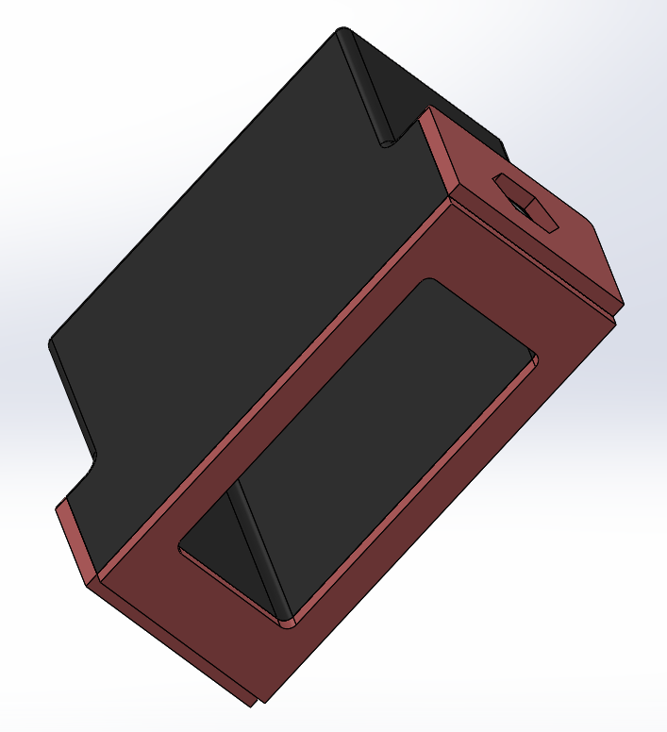

Assembly as of today:

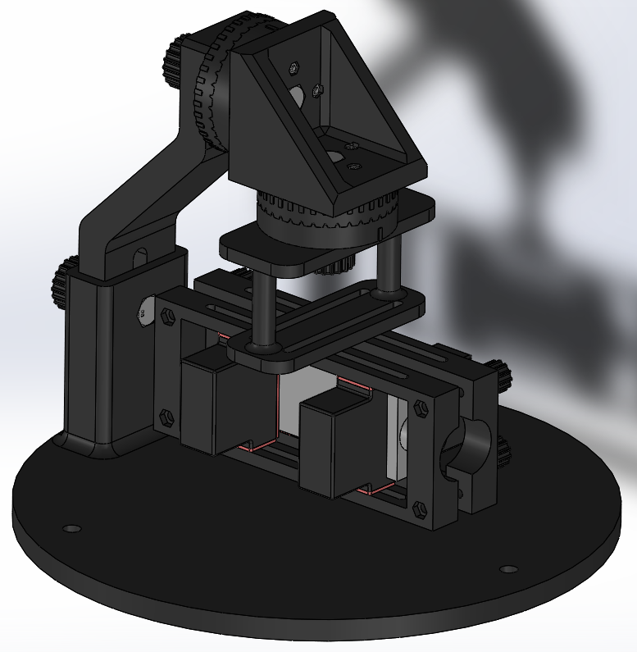

# 01/28/2020

The majority of the day was spent down in the lab getting acquainted with the test hardware.

Added all new mounting hardware to the build, sized the ID of the hoses for the thermal blocks, changed the design of the rail-to-stepper mount to allow for nut slots, decreased the size height of the rail-to-stepper, and finished all clearances. Also adjusted the slot in the back. I remobed the insulation from the sides of the thermal blocks to reduce complexity because I realized that the 3mm extension (that holds the nuts) on either side of the thermal block act as insulators already.

* **Adjust L-Bracket! (completed 01/21/20)**

Assembly as of today:

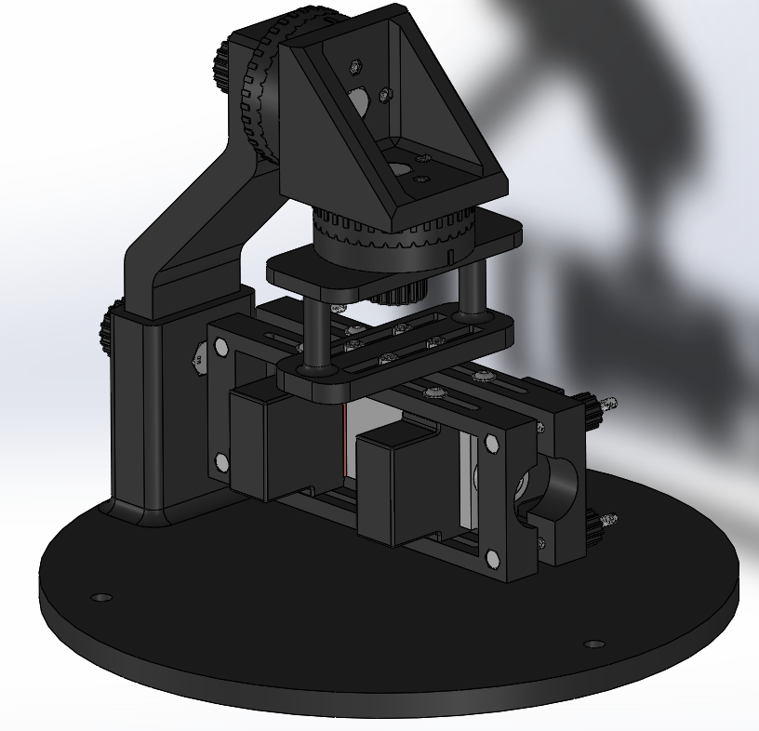

# 01/29/2020 - 02/05/2020

The end of last week and the beginning of this week ramped up. I’m working on 4 simultaneous projects at the moment: Building a test station, finishing my test stand, testing PMC materials, and helping with the airfoil cascade.

Regarding the test station, we (Phil and I) cannibalized parts from another apparatus, I sized our equipment and made some simple drawings to dimension the station. We went to the machine shop and cut a variety of metal parts (Phil also gave me a tour of the facility). Ezra and I assembled the station frame, then I sized then cut some plexiglass to fit, and Phil and Jeff cut it to size. Ezra, Phil and I then assembled the drilled and mounted the plexiglass.

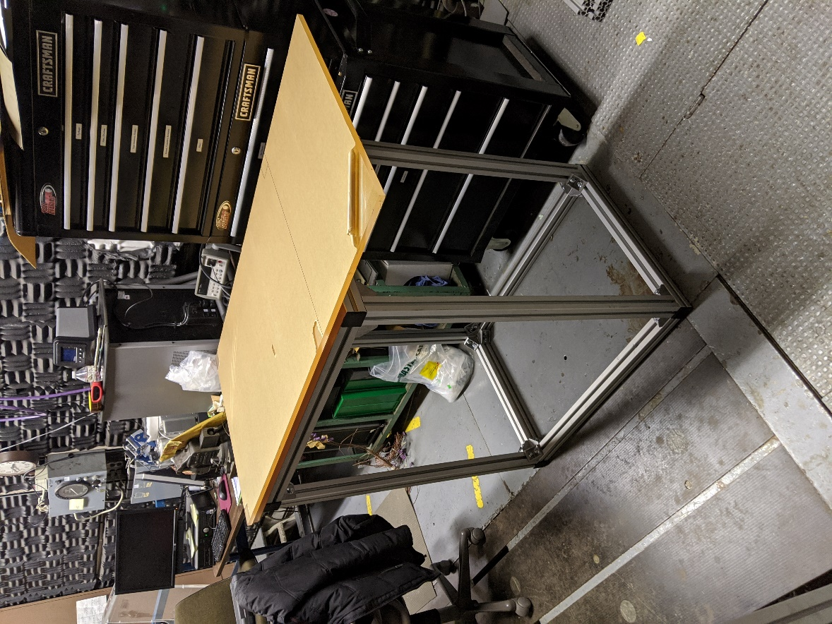

All the test stand parts were printed, the fasteners ordered, and the parts assembled. The only remaining task for the test stand is to order the gasket material for the thermal blocks (calculations completed today – 02/05/2020 – to find an appropriate type), and test the thermal blocks for leaks when running water through. Progress as of today:

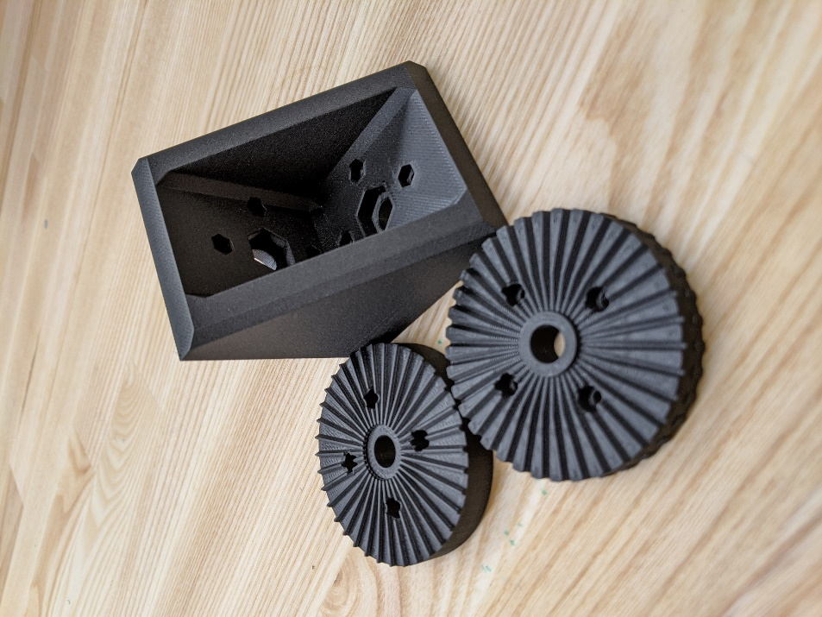

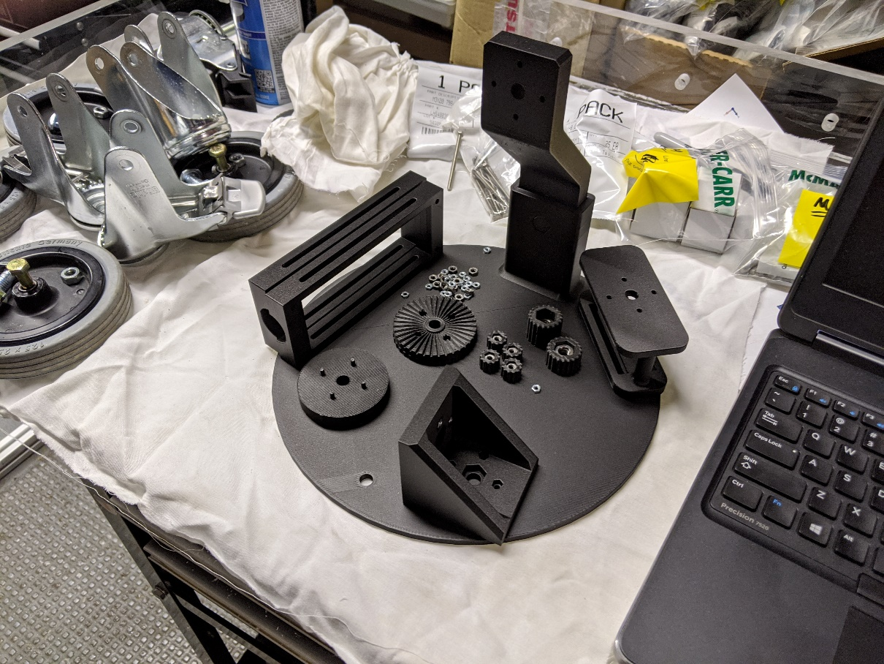

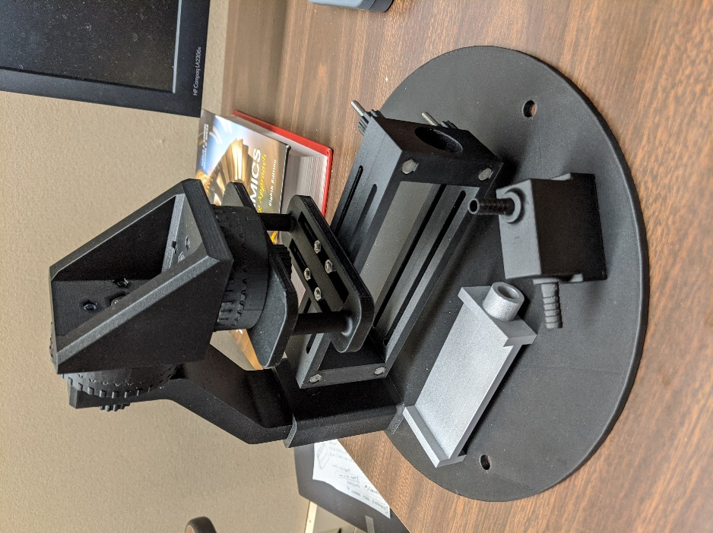

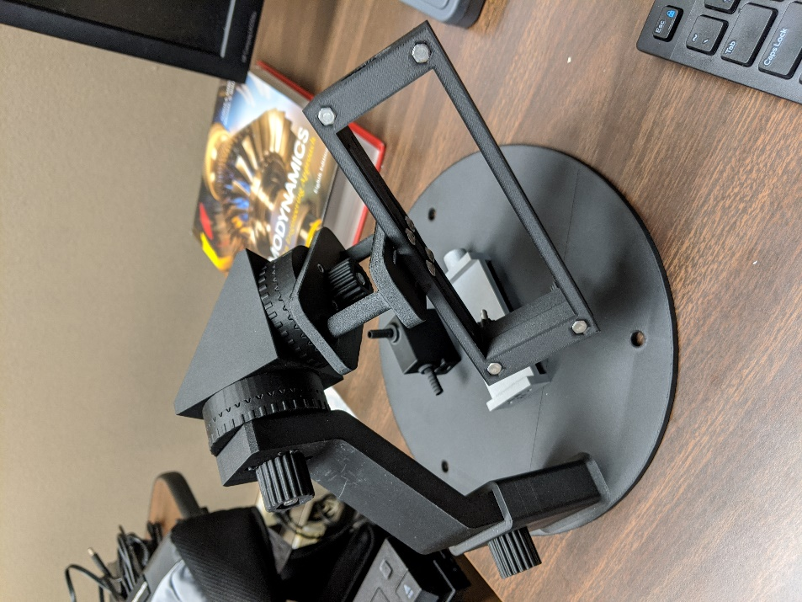

The thermal block being tested:

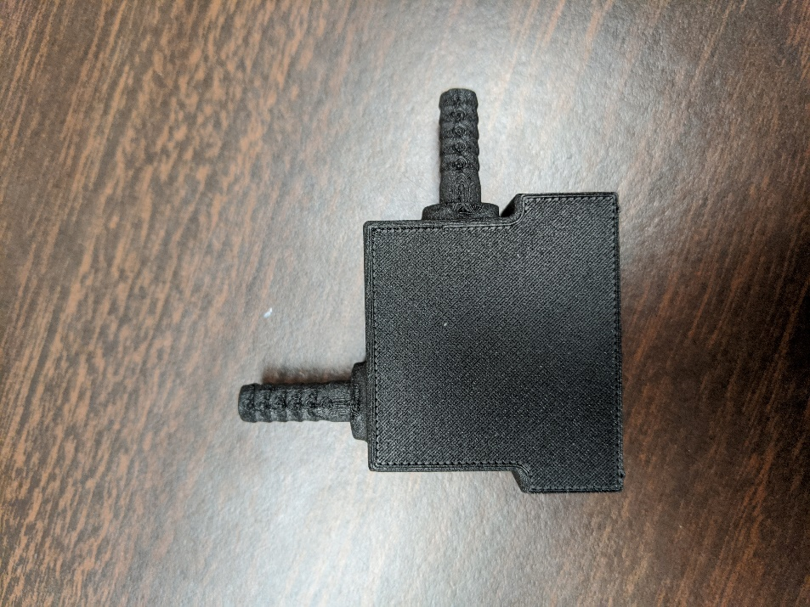  
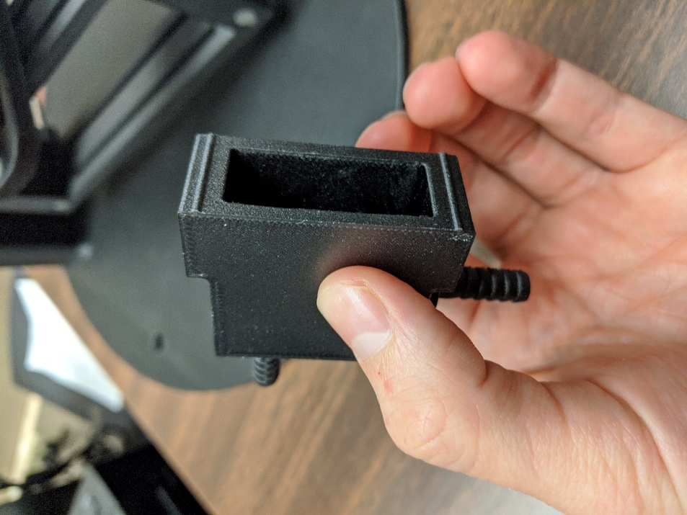

We’ll see if the 3D printed tube fittings are water tight. They look rough, which could warrant a redesign if that results in leaks.

The PMC testing involved Mack and I doing baseline work to figure out how the thermocouples performed in our configuration. After a variety of tests, and Ezra’s analysis of our data, we discovered that our results were not steady-state, and have concluded that more tests need to be completed. Mack has suggested that I take the lead on the testing so he can focus more on the machine learning aspect of the project. I’m considering learning LabView and rewriting the software created by the previous intern to be more applicable to what we are currently doing:

All I have helped with so far on the cascade is the alignment jig (I did very little, just helped Doug with a couple small issues in Solidworks. Here is the current state of that assembly:

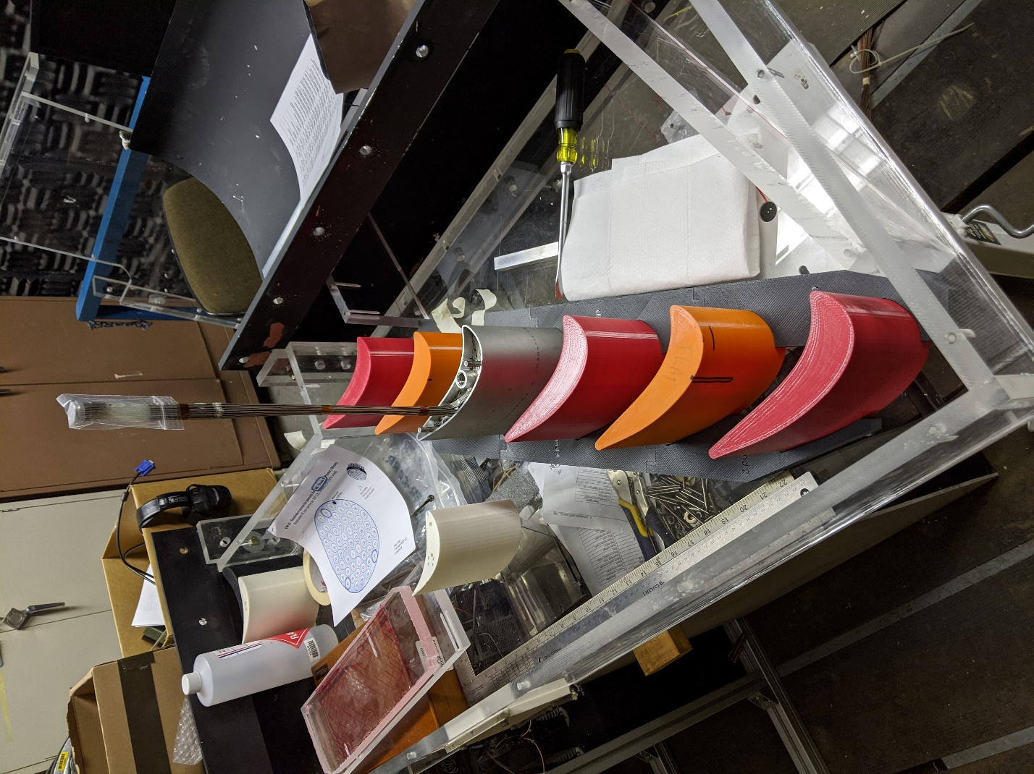

We finished assembling the station at the end of the day:

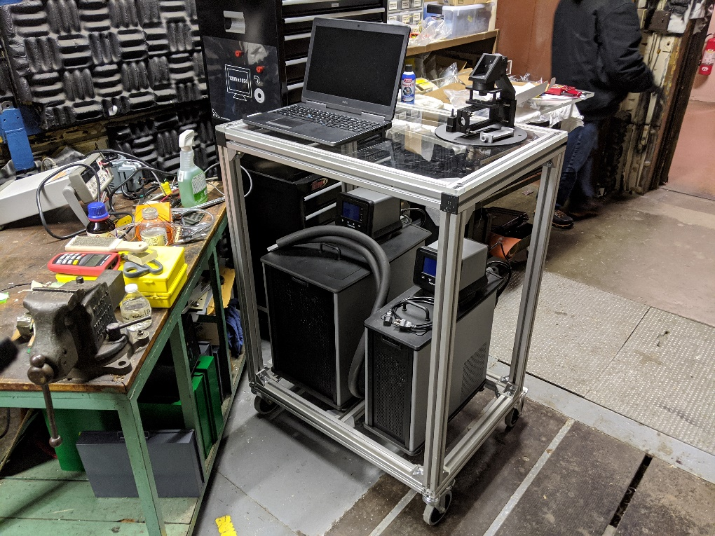

# 02/06/2020 – Small Redesign

The refrigerating and heating recirculators only have 2 hoses a piece, therefore we would need to use a splitter to use four thermal blocks on the test stand. Therefore, Ezra and I decided to add support blocks on one side of the heat-pipe test apparatus, and use only two thermal blocks on the other side. I printed a couple test support blocks which made me aware of an issue with easily aligning the test-apparatus:

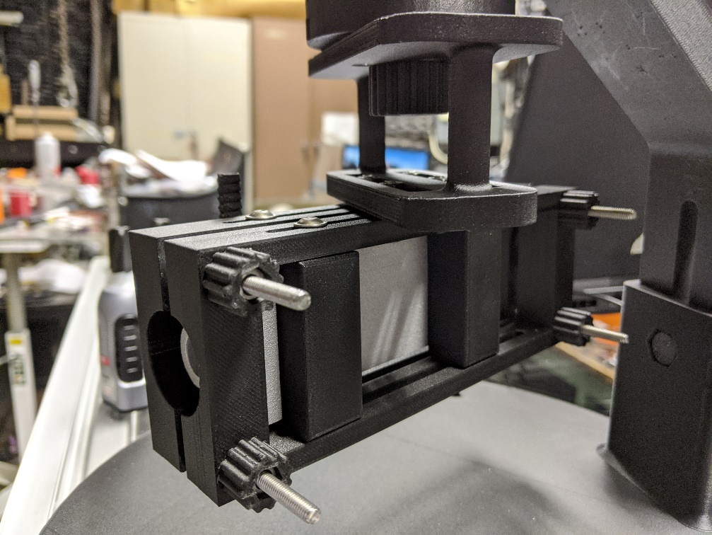

There is nothing keeping the support blocks from sliding up and down. I have electing to include guide tabs on both the thermal block and the support blocks to allow for easier assembly. Overall though, the method for holding the test apparatus in place should work quite well:

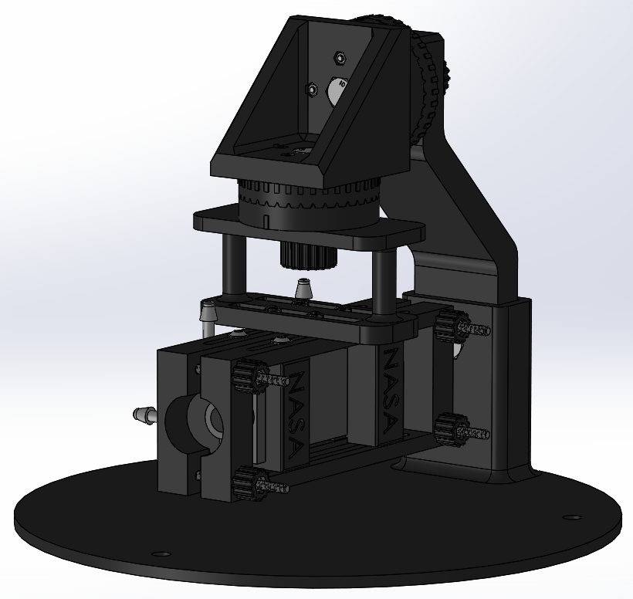

I have also redesigned the tube fittings. There was a lot of distortion with the print and I wasn’t sure how well it would hold, so I got a high-pressure design from McMaster and modified it to be more 3D printer friendly. I also included my own supports that I think will work better than the default supports. I’m trying both 0.1 mm and 0.2 mm support material z-separation distances. We’ll see which one works best!

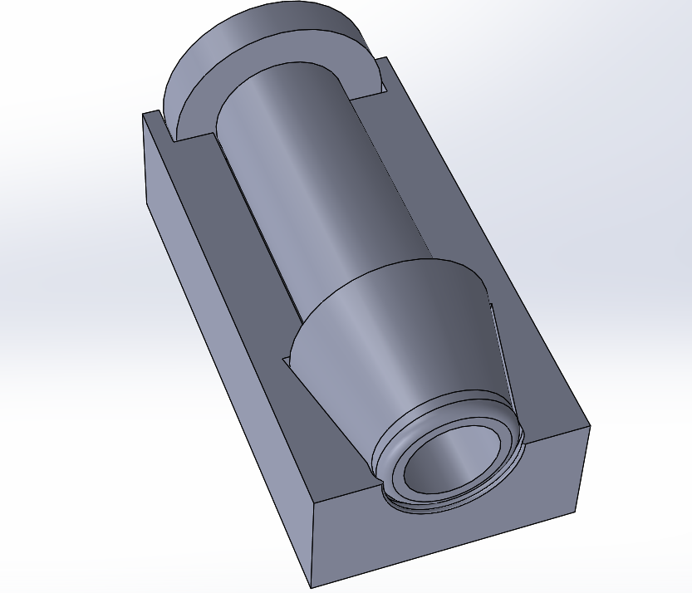

# 02/07/2020

After the test yesterday, I concluded that 0.2 mm distance between model material and support material is an acceptable balance between easy removal and proper support. The 0.1 mm test welded the support to the material and failed to remove.

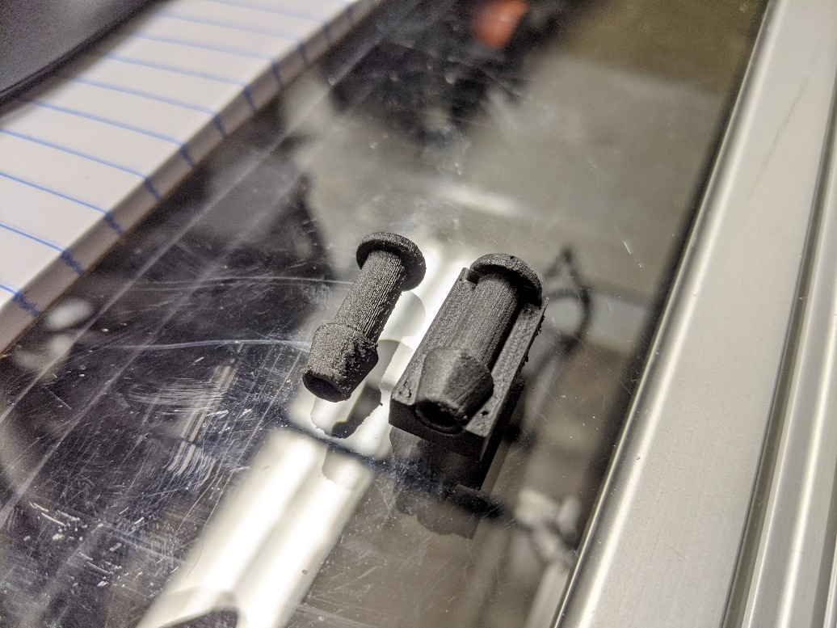

I printed the support blocks from yesterday:

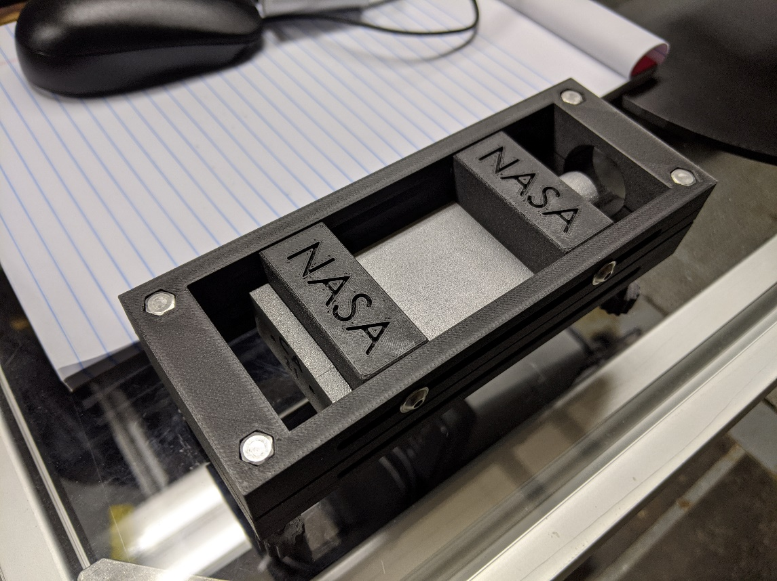

I continued iterating the tube fitting design, and refined the design of the thermal blocks:

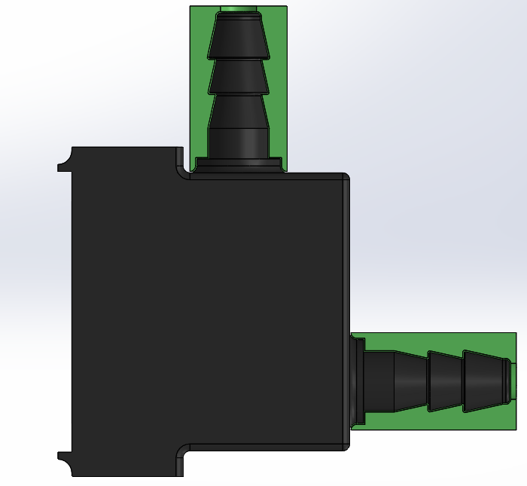

Here they are printed and attached:

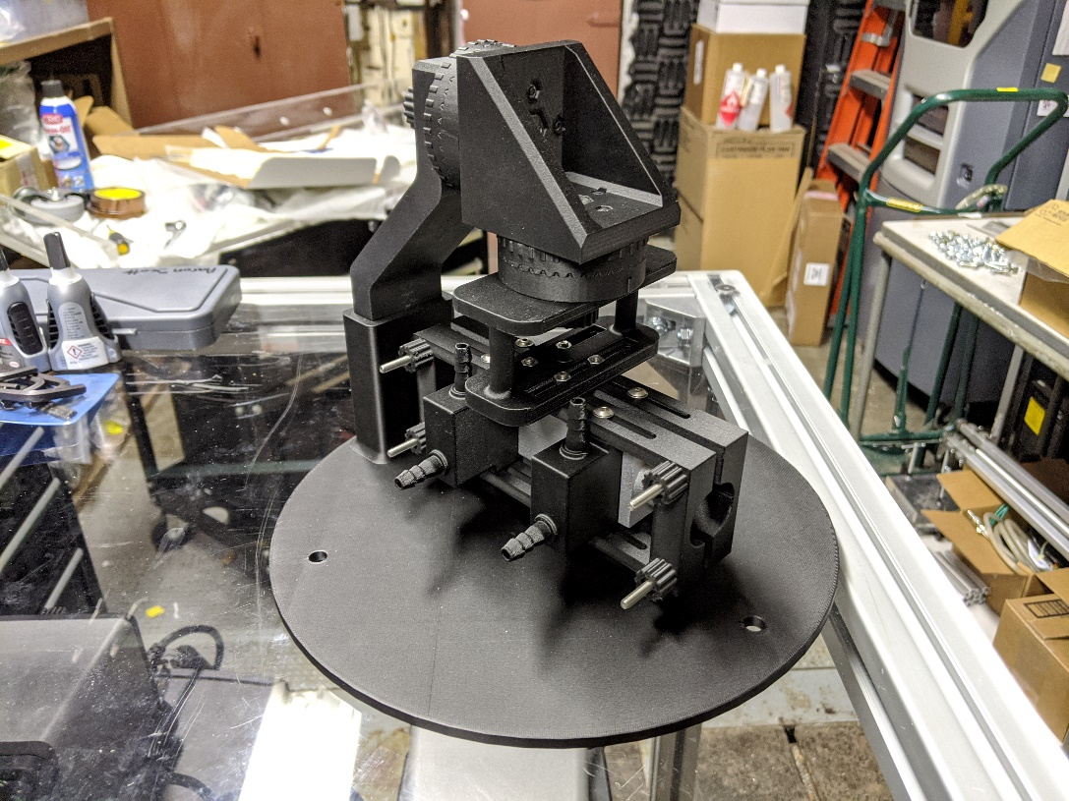

I tested for leaks and fitments and everything looks great.

At this point I am ready for testing. The only thing I am waiting on is the insulation material. As of today, I have tabulated that the prints have taken a total of 119 hours and 54 minutes to complete, with a total cost of $168.48, and total plastic mass usage of 790 grams. Almost a full spool.

The remainder of the day was spent studying LabView to familiarize myself with the software and potentially redesign the VI that will be used for the heat pipe testing.

Final version of the test stand 3D model(?):

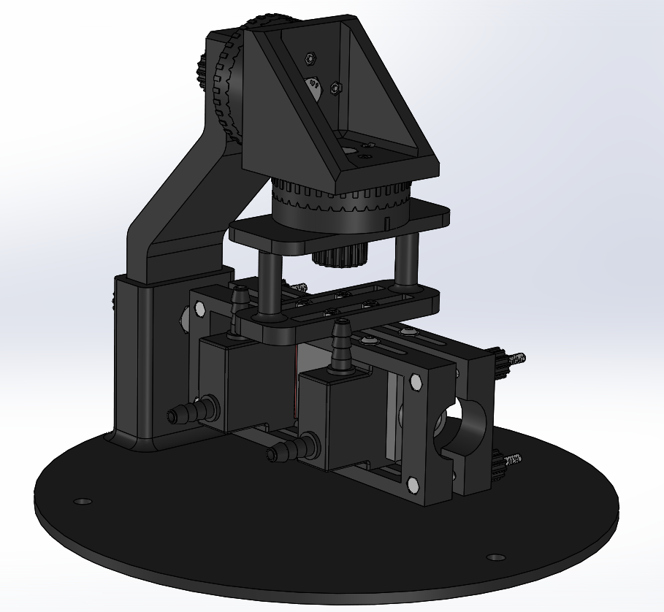

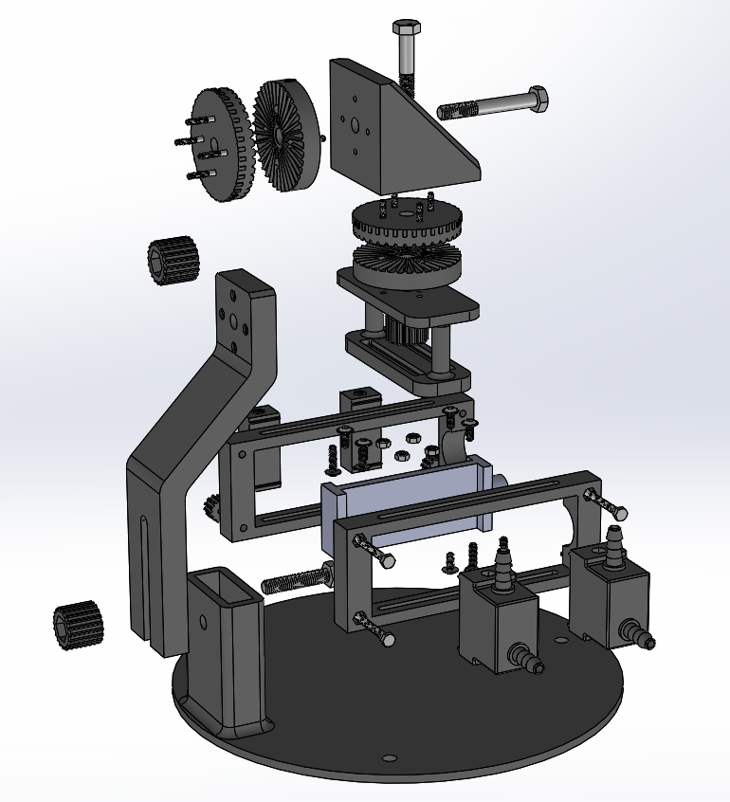

# 04/01/2020

In light of the COVID-19 Pandemic, a lot about my project changed. I am currently teleworking and working on COMSOL simulations for ~~the internal heat-pipe airfoils~~ the lattice wick heat pipes. However, there were some changes made to this model that I did not document.

First, I completed a major design overhaul because a fundamental element of the design of experiments changed after Arman, Doug, Phil, Ezra and I got together. Rather than focus on constant temperature boundaries for the I-beam heat pipe, we’ve decided to use liquid cooling at one end and a constant Q heat source on the other (electric heater). This reduces complexity in terms of the number of thermocouples required, as well as the number of mass flow meters. Arman also designed a first run-through test matrix, which requires different length ratios. Because my original design allowed the thermal blocks to be relative to each other, they were not sized to match this heater. Therefore, to achieve the ½, 1, and 2 length ratios, I had to print 3 new thermal blocks. Also, I was unable to access the laser printer because training is only available when there is enough interest, and the manufacturer of the high-temperature silicone (polysiloxane) gasket material would not provide a Material Safety Data Sheet. My workaround was to just cut the gasket material with an X-ACTO blade. I would not recommend this approach, but it will get the job done. Finally, the stand was mounted directly to the test station via a Unistrut channel. Note: The new mount between the Unistrut channel and the test stand needs to be printed to prevent flexing, but I am not on lab so this must be done by the next intern.

FINAL DESIGN:

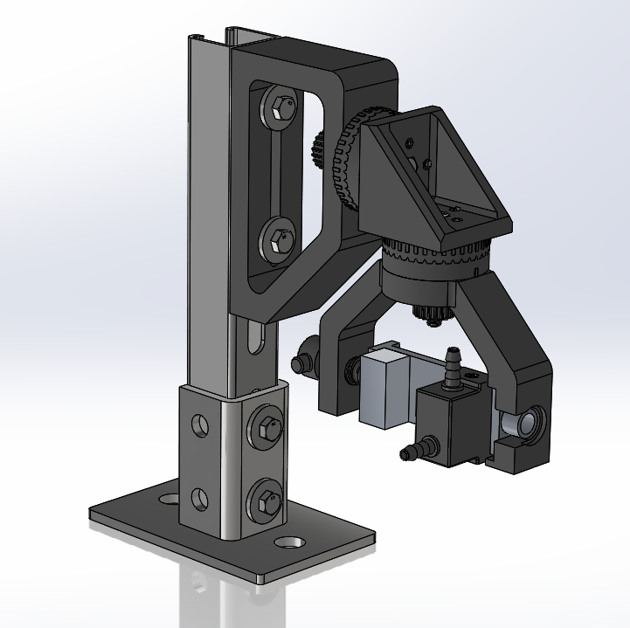

Also note that the heating block and cooling block must now be held onto the i-beam heat pipe. Even though it isn’t as fancy and integrated as my previous design, it is a more flexible solution.

New thermal blocks sized to fit the heater are named Double and Half corresponding to the length ratios we will be testing.